Assignment-4

|  |  |
| --- | --- |
| Date | 24 October 2022 |
| Name | RANJITH P |
| Roll Number | 620119106075 |
| Team ID | PNT2022TMID30896 |
| Project Name | SMART SOLUTION FOR RAILWAYS |

# Question :

Write code and connections in wokwi for ultrasonic sensors. That whenever distance is less than 100 cms send "alert" to ibm cloud and display in device recent events.

Upload document with wokwi share link and images.

# Wokwi:

**https://wokwi.com/projects/new/esp32**

# Code:

#include <WiFi.h> #include <PubSubClient.h>

WiFiClient wifiClient;

#define ORG "eswczz"

#define DEVICE_TYPE "Ranjith"

#define DEVICE_ID "Periyasamy"

#define TOKEN "3j_Rla1FWNEvQkbSV*

" #define speed 0.034

char server[] = ORG".messaging.internetofthings.ibmcloud.com"; char publishTopic[] = "iot-2/evt/status1/fmt/json"; char topic[] = "iot-2/cmd/home/fmt/String"; char authMethod[] = "use-token-auth"; char token[] = TOKEN;

char clientId[] = "d:" ORG ":" DEVICE_TYPE ":" DEVICE_ID;

PubSubClient client(server, 1883, wifiClient); void publishData(); const int trigpin=5; const int echopin=18; String command;

String data=""; long duration; float dist;

void setup()

{

**Serial**.begin(115200); pinMode(trigpin, OUTPUT);

pinMode(echopin, INPUT); wifiConnect(); mqttConnect();

} void loop() { publishData(); delay(500); if (!client.loop()) { mqttConnect();

}

}

void wifiConnect() {

**Serial**.print("Connecting to "); **Serial**.print("Wifi"); WiFi.begin("Wokwi-GUEST", "", 6); while (WiFi.status() != WL_CONNECTED) { delay(500);

**Serial**.print(".");

}

**Serial**.print("WiFi connected, IP address: ");

**Serial**.println(WiFi.localIP());

} void mqttConnect() { if (!client.connected()) {

**Serial**.print("Reconnecting MQTT client to ");

**Serial**.println(server);

while (!client.connect(clientId, authMethod, token))

{ **Serial**.print("."); delay(500);

}

initManagedDevice();

**Serial**.println();

} }

void initManagedDevice() { if (client.subscribe(topic)) { **Serial**.println("subscribe to cmd OK");

} else

{

**Serial**.println("subscribe to cmd FAILED");

} }

void publishData()

{ digitalWrite(trigpin,LOW); digitalWrite(trigpin,HIGH); delayMicroseconds(10); digitalWrite(trigpin,LOW); duration=pulseIn(echopin,HIGH); dist=duration*speed/2; if(dist<100){

String payload = "{\"Alert distance\":"; payload += dist; payload += "}"; **Serial**.print("\n"); **Serial**.print("Sending payload: "); **Serial**.println(payload);

if (client.publish(publishTopic, (char*) payload.c_str())){

**Serial**.println("Publish OK");

} else

{

**Serial**.println("Publish FAILED");

}

}

}

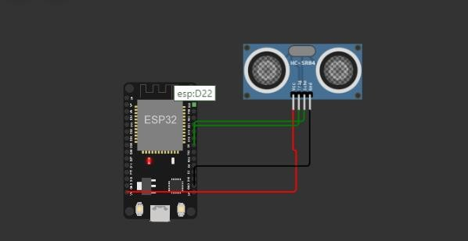**Diagram:**

# Wokwi Output:

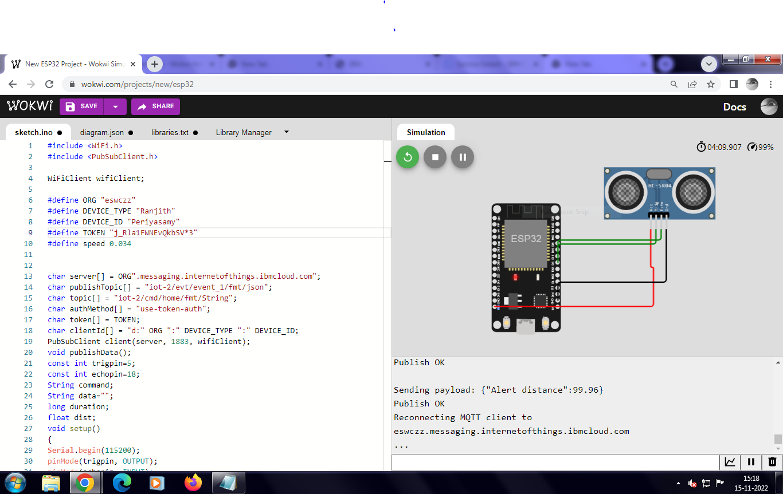

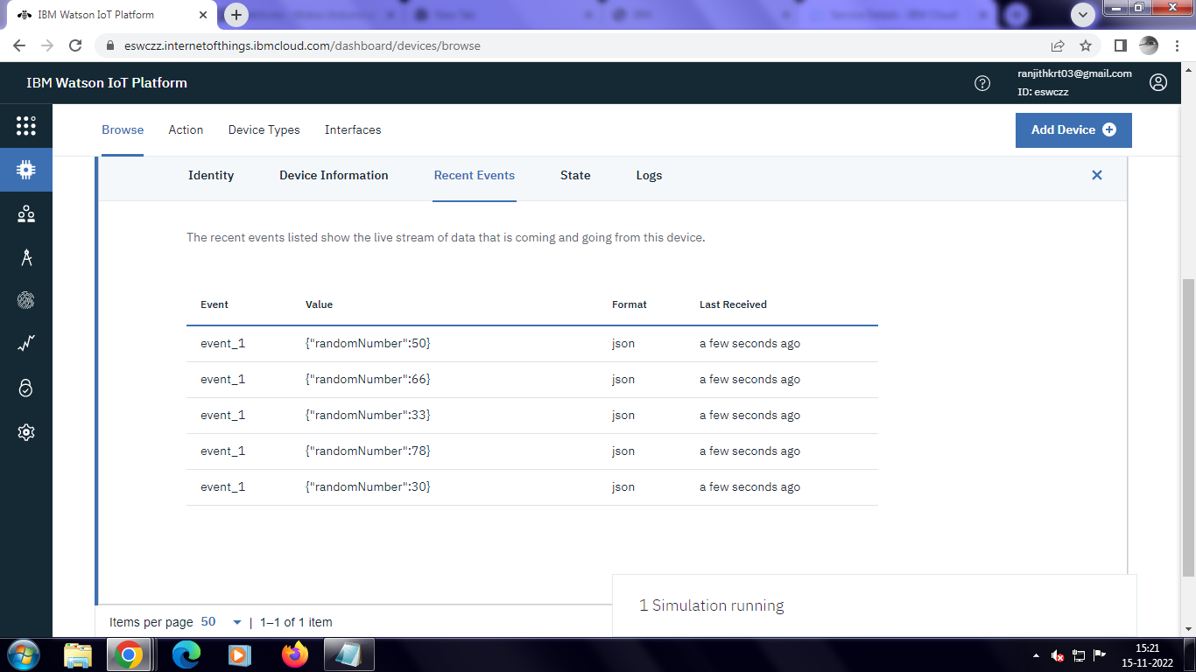

**IBM cloud output:**

